DESCRIPTION OF THE PROJECT

Studying the properties of pristine Graphene, Graphene with a stone wales defect, Graphene with a carbon vacancy defect and Graphene with both stone wales and carbon vacancy defects.

To start with, let me first give a brief description of the novel material Graphene.

1. What is Graphene and how does bonding occurs in it?

Graphene is a 2D material with hexagonal rings of sp2 hybridised carbons. The electronic configuration of graphene is 1s2, 2s2, 2p2. Here, we only take into consideration the valence electrons. Hence, the associated orbitals with the valence electrons are 2s, 2px, 2py, 2pz. Note: The electrons can fill any two of the p orbitals as they are all degenerate. The pz orbital is perpendicular to the plane of the 2D graphene.

All the carbons in graphene forms covalent bonds with the adjacent carbon atom. 3 sigma bonds are formed involving the orbitals 2s, 2px, 2py. The 2pz orbital overlaps with the 2pz orbital of the adjacent carbon atom resulting in delocalised $π$ (occupied or valence) and $π$*(unoccupied or conduction) bands.In the structure of graphene, we can see that on the 2D plane where the graphene is present, carbon forms ‘3’ sp2 bonds which gives graphene its strength. The 4th bond as carbon should form due to its valency being four lies vertically above and below the graphene sheet in the form of delocalised $π$ electrons. These delocalised electrons are smeared across the sheet of graphene, making it a highly conducting material (at least 6 times more conducting than the best copper conductor). These delocalised electrons present above and below the graphene sheet are not responsible in bringing about the strength in graphene.Basically, each carbon atom gives one electron to the valence band leaving the conduction band empty. This is the reason why the Fermi level lies exactly where the conduction and valence bands meet.

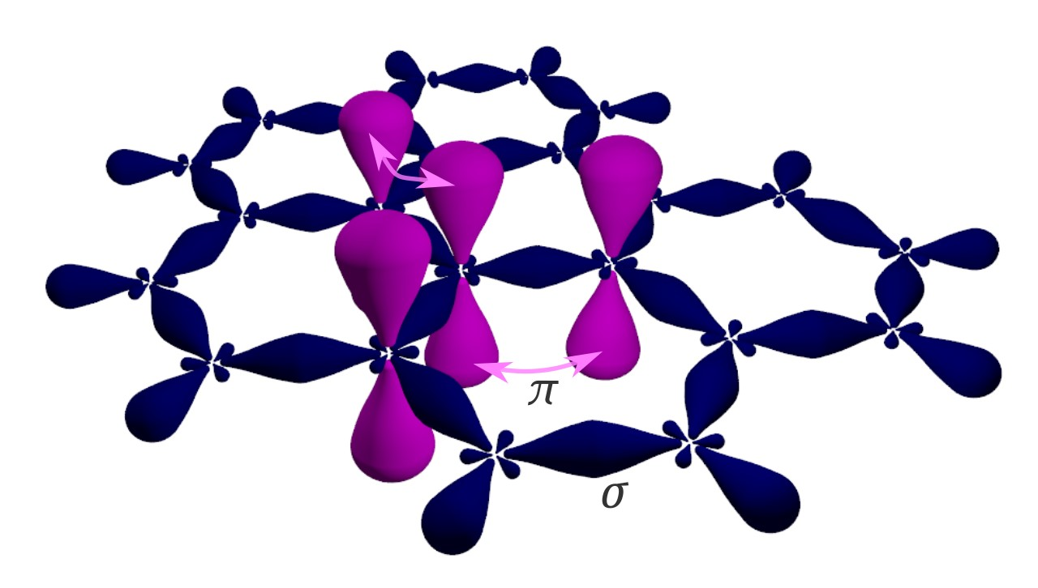

<https://en.wikipedia.org/wiki/Graphene#/media/File:Graphene_-_sigma_and_pi_bonds.svg>

Fig 1: represents bonding in Graphene.

1. What is Defect Formation energy and what is the defect formation energy of graphene with carbon vacancy defect and stone wales defect respectively?

Defect formation energy is the difference between the energy of crystal with defect and energy of perfect crystal. Another way of defining defect formation energy is the energy required for the formation of a defect in a crystal.Defects increase the energy of the crystal hence they are energetically unfavourable while presence of defects increases the entropy of the crystal which implies to the fact that it is entropically favourable.

defect - perfect

defect – perfect

defect – perfect

If $∆G<0$

Then it is said to be favourable. This happens when the Gibbs free energy of crystal with defect is less than crystal which is perfect.

Also,

If the temperature is low, then T $∆S$ tends to be very small leading to a positive Gibbs free energy which is unfavourable. This all makes sense because at low temperatures we have very less defects but at higher temperatures there are more defects. This occurs because at higher temperatures there are more vibrations which cause the atoms to leave their place in the lattice to form defects.

These kinds of defects where the atoms leave their place in the lattice creating vacancies are called point defects. Single vacancy defect, multiple vacancy defect are all examples for point defect.

|  |  |  |  |  |
| --- | --- | --- | --- | --- |
| Sr. No. | Defect | Defect Formation Energy | Paper Name | Paper Link |
| 1. | Single Carbon vacancy defect | 7.62eV | Energetic stability, STM fingerprints and electronic transport properties of defects in graphene and Silicene | [https://www.researchgate.net/publication/289525586_Energetic_stability_STM_fingerprints_and_electronic_transport_properties_of_defects_in_graphene_and_silicene](https://bitmesra-my.sharepoint.com/:w:/g/personal/btech10284_21_bitmesra_ac_in/EWqhcc-pYNZNgMl_llmbzRsBJyhGXiR0UUhHuHfaibP6Fw) |
| 2. | Stone Wales | 4.87eV | Energetic stability, STM fingerprints and electronic transport properties of defects in graphene and Silicene | [https://www.researchgate.net/publication/289525586_Energetic_stability_STM_fingerprints_and_electronic_transport_properties_of_defects_in_graphene_and_silicene](https://bitmesra-my.sharepoint.com/:w:/g/personal/btech10284_21_bitmesra_ac_in/EWqhcc-pYNZNgMl_llmbzRsBJyhGXiR0UUhHuHfaibP6Fw) |

Ahead is the description of how I moved ahead with the project.

1) To get started, a 7*7 supercell of graphene was taken.

2) Then a vacuum was introduced in it (min 20 more than the original value) from the lattice parameters section.

3) Introduction of vacuum was required to eliminate any interactions with the adjacent unit cell.

4) After this the unit cell was aligned in the centre.

1. This structure was further used for obtaining other structures required for the study like graphene with stone wales defect (rotate one of the c=c by an angle of 90 degrees in the plane of graphene), graphene with carbon vacancy defect (delete one of the carbon atoms from the sheet), graphene with both stone wales defect and carbon vacancy defect.
2. Firstly, we take into consideration spin unpolarized.
3. We select the LCAO calculator.

* Here we need to make sure during setting of parameters that the sampling has been set to an odd integer (in this case we took it as 13*13)
* Another thing to be noted is if we are dealing with a unit cell that has two atoms in the case of graphene, its reciprocal (Brillouin zone) would be bigger than that of its supercell. So, while dealing with a unit cell we require more k sampling points than in the case of supercell due to its reciprocal being smaller.
* Now, when we are taking parameters like mesh parameter and k points sampling parameter, we need to optimise these. Here, optimising means reducing the computational expense. In this step from the analysis section, we choose chemical potential. To optimise these parameters, we need to bring in the change in the python code. While changing the code, we need to select the range for the for loop and decide upon an appropriate no. of iterations.
* After bringing about the change in code, we get some coordinates in the end of the log file which needs to be plotted. After plotting we are supposed to select the appropriate value, as there should not be much of a variation in the chemical potential after the value we have selected. From the graph we get a value for k sampling and mesh grid.
* In LCAO Basis set we select Dispersion Correction and there ‘Grimme DFT-D2’ is selected to bring into consider the Vander waal’s forces.
* Counterpoise => for adsorbing
* Poisson => FFT

1. Now we take spin polarized into consideration.

* When we take spin polarised into consideration, we selected the following from the analysis block: -

1. Density of states
2. Electron density
3. Electron localisation Function
4. Fat band structure (for both spin up/ down and elements and orbitals)
5. Total energy

* Exchange Correlation: GGA
* Pseudo Potential: Pseudodojo
* From the graph after optimisation: (For our case)

1. Density Mesh Cut-Off: 60
2. Sampling: 6*6*1
3. Then we select optimisation which opens several options, and we again select geometry optimisation in there. (The acceptable value for force tolerance is 0.01 to 0.05, we generally stick to 0.01) Reason being optimisation is required to bring stability to the system. By optimising we have selected the lowest potential system and we have made it follow the second theorem of Density Functional Theorem (DFT) which is based on the variational principle by the means of which we can find the lowest energy of the system and hence making it more stable.
4. Another thing that is worth mentioning is, when we had taken into consideration spin polarised, we used the bulk configuration 1 which we had obtained while calculating for spin unpolarized. It was done this way because it immensely reduces the time required for the calculations as it becomes easier to find the lowest energy possible if it is already at a lower value. If this had not been the case, then the time taken for these calculations would have taken quiet a significant amount of time than it took in this case.
5. We select optimization: -
6. In optimisation we go for geometry optimisation.
7. There we set the following as: -
8. Force tolerance: 0.01 eV/A
9. Stress error tolerance: 0.001 eV/Ang3
10. Maximum number of steps: 200
11. Untick” fix lattice vectors”.
12. One of the problems I faced during the running of simulations was in the case of graphene with a carbon vacancy. It was not getting converged, so we had to bring about some changes in the LCAO calculator to get it converged.
    1. We select the iteration control in LCAO Calculator
    2. There we set the following as: -
13. Tolerance: 0.0001
14. Max steps: 200
15. Damping factor: 0.01
16. Number of history steps: 20
17. After having run the simulations and obtaining the results, I analysed graphs of the results obtained. I did the analysis to various graphs namely, the plots of electron density, electron localisation function, fat band structures, and density of states.
18. Total energies of all the structures were compared the results were analysed.